Applicable scope

The DAM3PV series moulded case circuit breaker is suitable for DC power grid circuit and solar photovoltaic system with maximum rated voltage of DC1500V and rated current of 800A. It has overload and short circuit protection function,used to distribute electrical energy and protect circuit and power equipment from overload, short circuit and other faults.

Normal working condition

◎Ambient air temperature
◎The upper limit of ambient air temperature is +40°C
◎The lower limit of ambient air temperatureis -5°C
◎The average temperature of the surrounding air within 24 hours shall not exceed +35°C
◎Altitude: The altitude of the installation site shall not exceed 2000m
◎The relative humidity of the atmosphere does not exceed 50% when the ambient air temperature is +40°C. At lower temperature,there can be higher relative humidity. The average maximum humidity in the wettest month is 90%, and the average minimum temperature in that monthis +25°C, and the condensation on the product surface due to temperature change should be considered.
◎Pollution level: 3

Usage and maintenance

The various characteristics and accessories of the circuit breaker are set by the manufacturer and cannot be adjusted arbitrarily during use. Under the conditions ofuser’S compliance with storage and usage, the circuit breaker seal shall be intact within 24 months from the date of shipment from the manufacturer. If the product is damaged or cannot be used normally due to manufacturing quality problem, the manufacturer shall be responsible for free replacement and repair.

Main technical parameter Table 2
Rated frame current Inm (A) | 250 |  |  | 250 |  | 320 |  | 400 |  |  | 630 |  | 800
Model | DAM3PV  -250 |  |  | DAM3PV  -250HU |  | DAM3PV  -320HU |  | DAM3PV  -400HU |  |  | DAM3PV  -630HU |  | DAM3PV  -800HU
Rated current In (A) | 100A、125A、  140A、160A、  180A、200A、  225A、 250A |  |  | 125A、 140A、  160A、 180A、  200A.、225A、  250A |  | 280A、 315A、  320A |  | 225A、250A、  315A、350A、  400A |  |  | 400A、500A、  630A |  | 630A、700A、  800A
Number of poles | 2 | 3 | 4 | 2 | 3 | 2 | 3 | 4 |  |  | 4 |  | 4
Rated working voltage Ue (V) DC | 500 | 750 | 1000 | 1000 | 1500 | 1000 | 1500 | 1000 | 1250 | 1500 | 1000 | 1500 | 1000 | 1250 | 1500
Rated insulation voltage Ui (V) | 1250 |  |  | 1250 | 1500 | 1250 | 1500 | 1500 |  |  | 1500 |  | 1500
Rated impulse withstand voltage  Uimp(kV) | 12 |  |  | 8 | 12 | 8 | 12 | 12 |  |  | 12 |  | 12
Ultimate short-circuit  breaking capacity icu (kA) | 40 |  |  | 20 | 20 | 20 | 20 | 20 |  |  | 20 |  | 20
Service short-circuit  breaking capacity Ics (kA) | 20 |  |  | 20 | 20 | 20 | 20 | 20 |  |  | 20 |  | 20
Wiring method | See attached  diagram |  |  | See attached  diagram |  | See attached  diagram |  | See attached  diagram |  |  | See attached  diagram |  | See attached  diagram
Installation method | Fixed and  plug-in |  |  | Fixed and plug-in |  | Fixed and plug-in |  | Fixed and plug-in |  |  | Fixed and plug-in |  | Fixed and plug-in
Mechanical life (total number of times) | 8000 |  |  | 8000 |  | 8000 |  | 5000 |  |  | 5000 |  | 3000
Electrical life (total number of times) | 1000 |  |  | 1000 |  | 1000 |  | 1000 |  |  | 1000 |  | 1000
With isolation characteristic or not | Yes |  |  | Yes |  | Yes |  | Yes |  |  | Yes |  | Yes
Allowable usage ambient  temperature ("C) | -5℃~+40℃ |  |  | -5℃~+40℃ |  | -5℃~+40℃ |  | -5℃~+40℃ |  |  | -5℃~+40℃ |  | -5℃~+40℃
Protection level | IP20 |  |  | IP20 |  | IP20 |  | IP20 |  |  | IP20 |  | IP20
Accessory attachable | Auxiliary,shunt,  alarm,manual  operation, electric  operation |  |  | Auxiliary,shunt.  alarm,manual  operation, electric  operation |  | Auxiliary,shunt,  alarm, manual  operation, electric  operation" |  | Auxiliary,shunt,  alarm,manual  operation, electric  operation |  |  | Auxiliary,shunt,  alarm, manual  operation, electric  operation |  | Auxiliary,shunt,  alarm,manual  operation, electric  operation
Instantaneous action value | 10in |  |  | 10In |  | 10ln |  | 10in |  |  | 10in |  | 10in
Arc distance (mm) | ≤50 |  |  | ≤50(0 with cover) |  | ≤50 (0 with cover) |  | ≤50 (0 with cover) |  |  | ≤50 (0 with cover) |  | ≤50(0 with cover)
Outline dimension  (L×W×H)(mm) | 2P:165×72×127  3P:165x107x127  4P:165×142×127 |  |  | 2P:180×76×126  3P:180x107x126 |  | 2P:180×76×126  3P:180x107x126 |  | 258×200×107 |  |  | 280×280×116 |  | 280×280×116

Wiring method: DC product wiring diagram
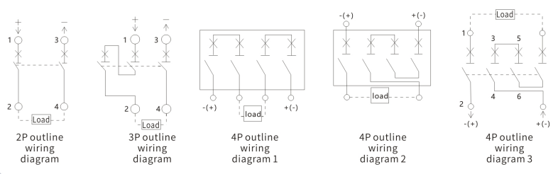

Circuit breaker action characteristic curve
M3- (HU) action characteristic curve DAM3PV action characteristic curve

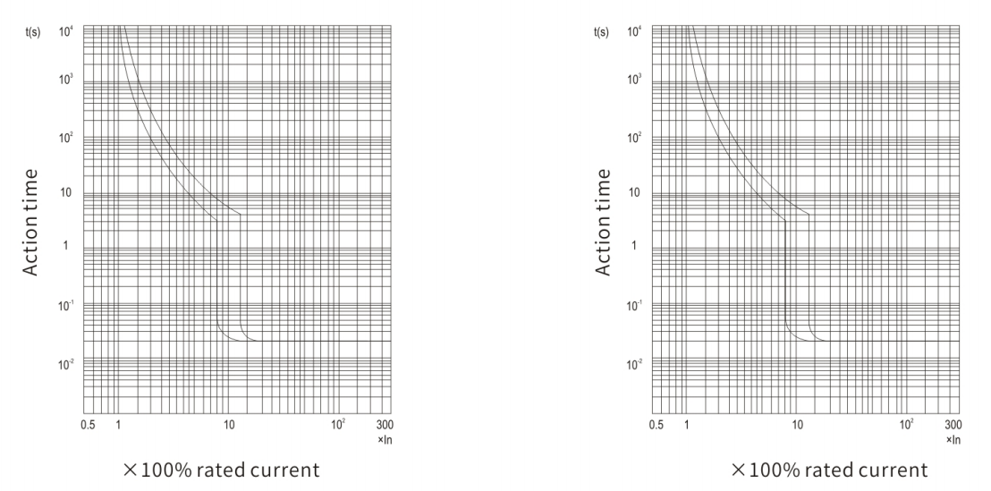

Safety distance during circuit breaker installation
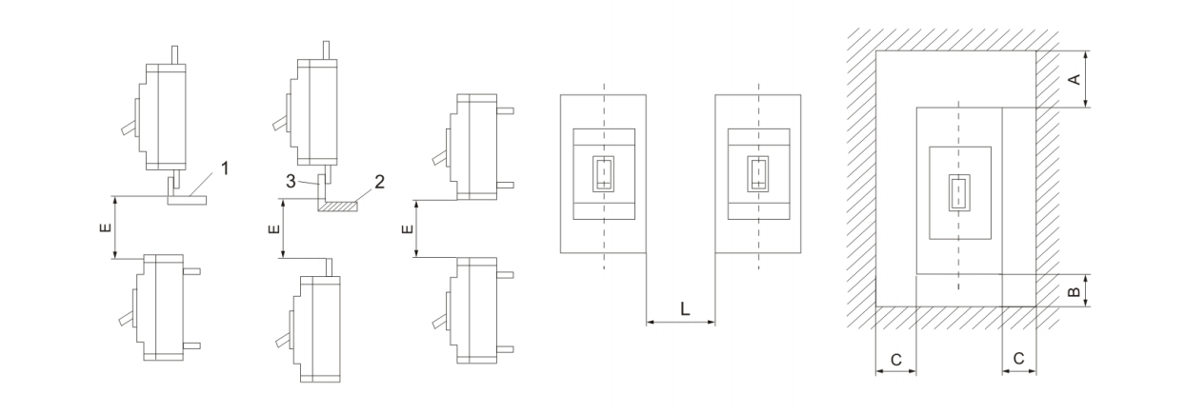
Model | L | A |  | B | C | E
Model | L | With zero arc cover | Without zero arc cover | B | C | With zero arc cover | Without zero arc cover
DAM3PV-250/320HU | 40 | 50 | 30 | 25 | 25 | 60 | 60
DAM3PV-400HU | 40 | 50 | 30 | 25 | 25 | 60 | 60
DAM3PV-800HU | 70 | 100 | 30 | 25 | 25 | 100 | 60
 | In the figure: 1. No insulation connection; 2 insulated wires; 3 cable terminal

Release method and accessory code
Classification by release type: only instantaneous release (electromagnetic release:200); Thermal+electromagnetic release
(complex type: 300)


Outline and installation dimension

DAM3PV-250 outline and installation dimension
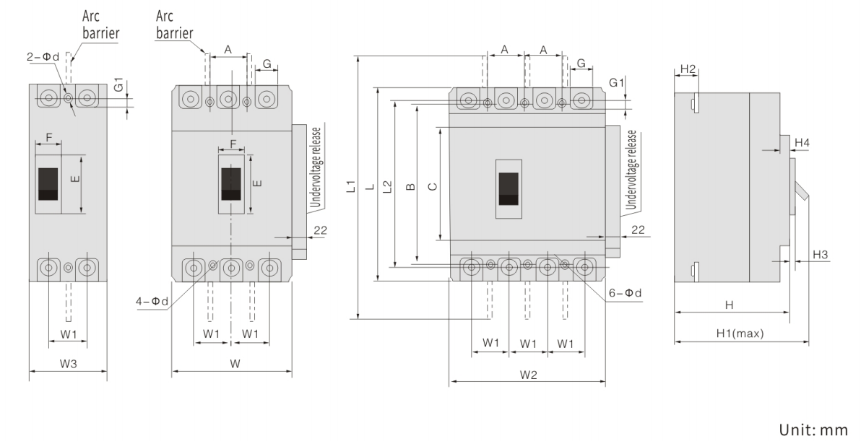
Outline dimension |  |  |  |  |  |  |  |  |  |  |  |  |  |  |  |  | Installation dimension
C | E | F | G | G1 | H | H1 | H2 | H3 | H4 | し | L1 | L2 | W | W1 | W2 | W3 | A | B | d
102 | 50 | 22 | 23 | 11.5 | 103 | 127 | 23 | 4 | 5 | 165(171 with protective cover) | 360 | 144 | 107 | 35 | 142 | 72 | 35 | 126 | φ5

DAM3PV-250/320HU outline and installation dimension
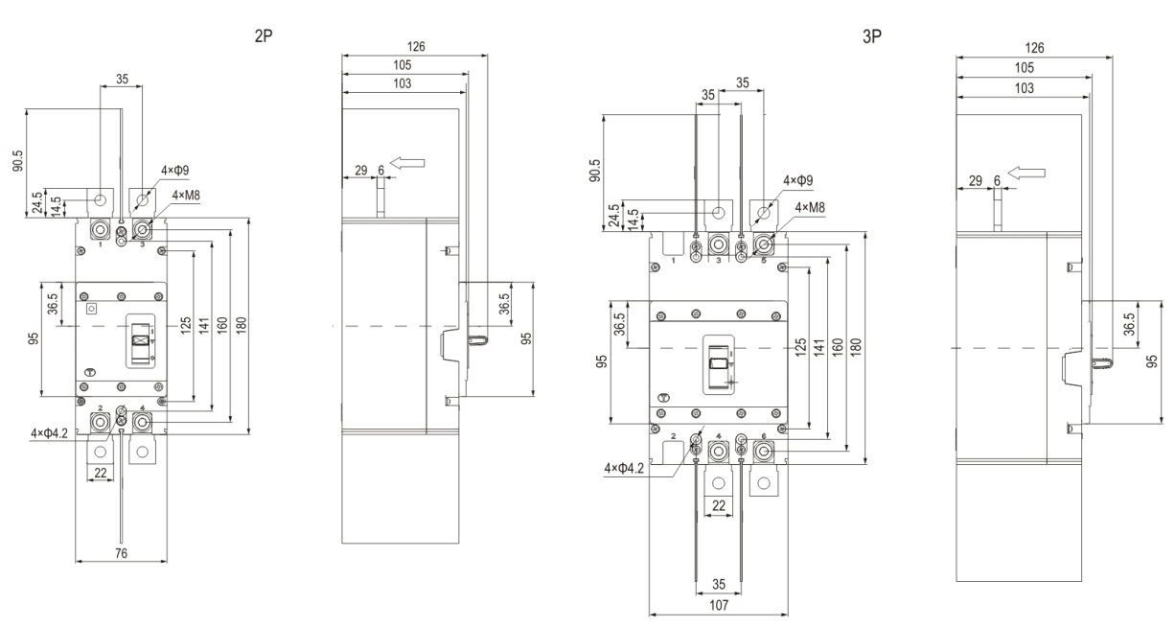
DAM3PV-400HU outline and installation dimension
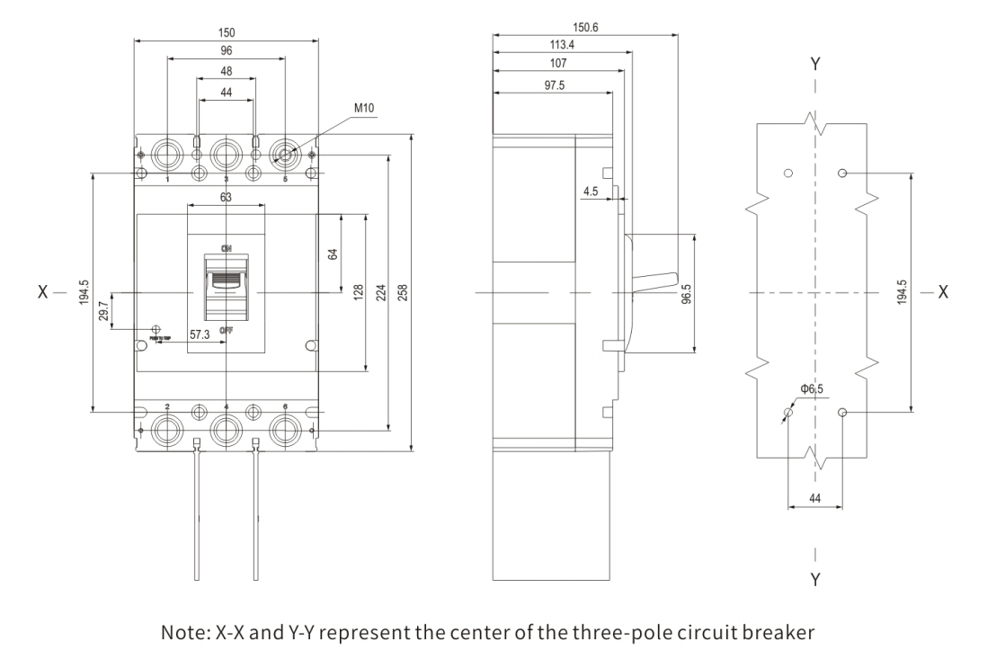

M3(DC) -400 outline and installation dimension (except for M3-400HU)
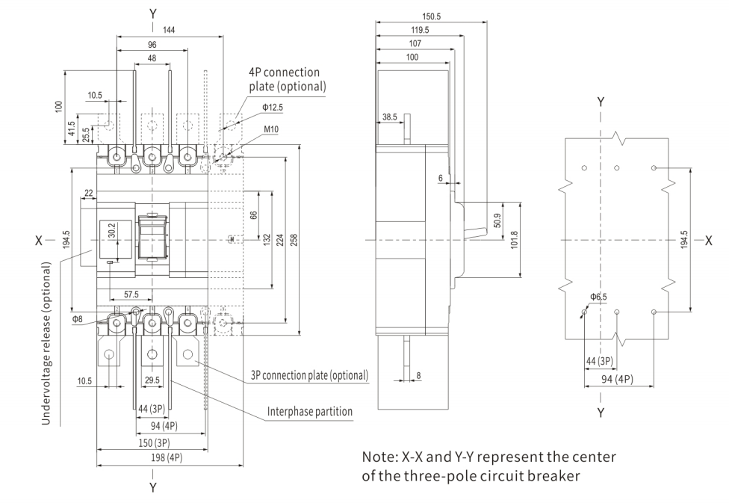
DAM3PV-630/800HU outline and installation dimension
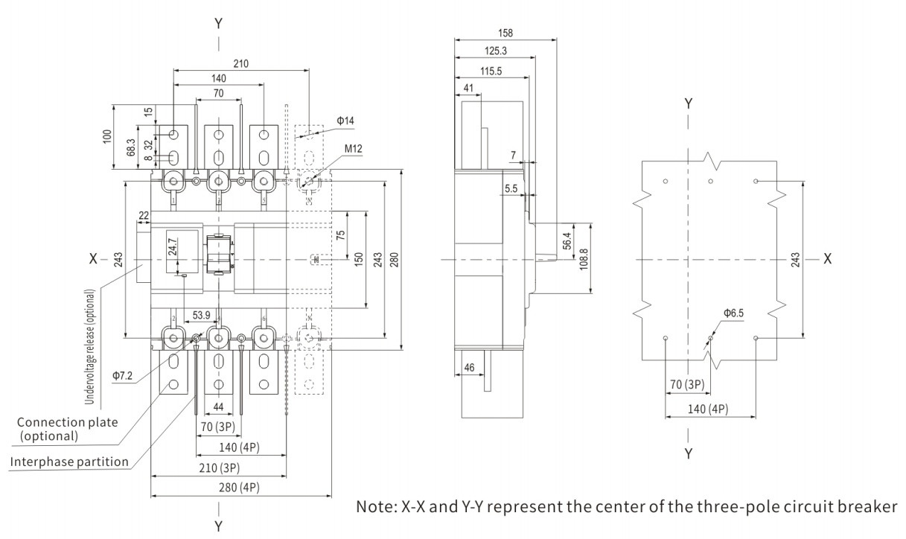

Installation diagram of DAM3PV with arc cover
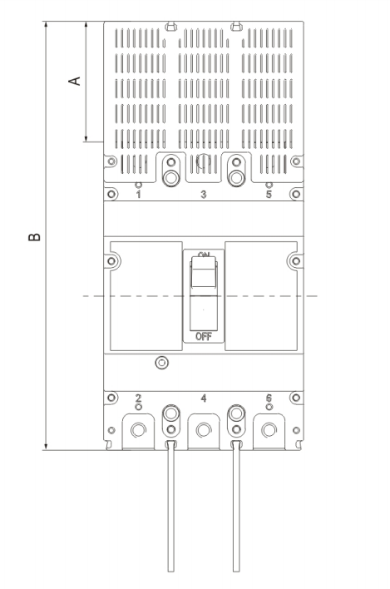

Model | Arc cover length A | Total length B
DAM3PV-250/320HU | 69 | 234
DAM3PV-400HU | 72 | 330
DAM3PV-630/800HU | 67.5 | 347.5

